**Unit- 1**

**M2M to IoT _ the Vision**

**2.1 Introduction**:

Our world is on the verge of an amazing transformation; one that will affect every person, town, company, and thing that forms the basis of our society and economy.

In the same way that the Internet redefined how we communicate, work, and play, a new revolution is unfurling that will again challenge us to meet new business demands and embrace the opportunities of technical evolution. In response to these Issues, we are moving towards a new era of intelligence one driven by rapidly growing technical capabilities.

M2M and the IoT are two of the technologies that form the basis of the new world that we will come to inhabit. Anything in the physical realm that is of interest to observe and control by people, businesses, or organizations will be connected and will offer services via the Internet. The physical entities can be of any nature, such as buildings, farmland, and natural resources like air, and even such personal real-world concepts as my favorite hiking route through the forest or my route to work.

**2.2 From M2M to IoT**

Machine-to-Machine communication towards an emerging paradigm known as the **Internet of Things.** This chapter provides definitions of two terms and sets the stage for the rest of the book by outlining the global trends, capabilities, and drivers towards

**2.2.1 A brief background:**

Both M2M and IoT are results of the technological progress over the last decades, including not just the decreasing costs of semiconductor components, but also the spectacular uptake of the Internet Protocol (IP) and the broad adoption of the Internet. The application opportunities for such solutions are limited only by our imaginations; however, the role that M2M and IoT will have in industry and broader society is just starting to emerge for a series of interacting and interlinked reasons.

The Internet has undoubtedly had a profound impact across society and Industries over the past two decades. Starting off as ARPANET connecting Remote computers together, the introduction of the TCP/IP protocol suite, and later the introduction of services likes email and the World Wide Web (WWW), created a tremendous growth of usage and traffic. In conjunction with innovations that dramatically reduced the cost of semiconductor technologies and the subsequent extension of the Internet at a reasonable cost via mobile networks, billions of people and businesses are now connected to the Internet. Quite simply, no industry and no part of society have remained untouched by this technical revolution.

At the same time that the Internet has been evolving, another technology

Revolution has been unfolding:

- The use of sensors, electronic tags, and actuators to digitally identify, observe and control objects in the physical world.

- Rapidly decreasing costs of sensors and actuators have meant that where such components previously cost several Euros each, they are now a few cents.

- As a result, they are able to communicate information about the physical world in near real-time across networks with high bandwidth at low relative cost.

- In addition, these devices, through increases in the computational capacity of the associated chipsets, are now able to communicate via fixed and mobile networks.

- As a result, they are able to communicate information about the physical world in near real-time across networks with high bandwidth at low relative cost.

So, while we have seen M2M solutions for quite some time, we are now entering a period of time where the uptake of both M2M and IoT solutions will increase dramatically. The reasons for this as following:

1. An increased need for understanding the physical environment in its various forms, from industrial installations through to public spaces and consumer demands. These requirements are often driven by efficiency improvements, sustainability objectives, or improved health and safety (Singh 2012).

2. The improvement of technology and improved networking capabilities.

3. Reduced costs of components and the ability to more cheaply collect and analyze the data they produce.

M2M and IoT markets take off today, therefore, is needs meeting enabling technologies at the right cost.

**2.2.2 M2M communication:**

M2M refers to those solutions that allow communication between devices of the same type and a specific application, all via wired or wireless communication Networks.

M2M solutions allow end-users to capture data about events from assets, such as temperature or inventory levels.

M2M is deployed to achieve productivity gains, reduce costs, and increase safety or security.

M2M has been applied in many different scenarios, including the remote monitoring and control of enterprise assets, or to provide connectivity of remote machine-type devices.

Remote monitoring and control has generally provided the incentive for industrial applications, connectivity has been the focus in other enterprise scenarios such as connected vending machines or point-of-sales terminals for online credit card transactions

**2.2.2.1 A typical M2M solution overview:**

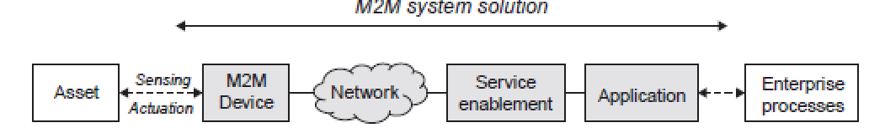

**FIG. 2.1:** A generic M2M system solution

A typical M2M system solution consists of M2M devices, communication networks that provide remote connectivity for the devices, service enablement and application logic, and integration of the M2M application into the business processes provided by an Information Technology (IT) system of the enterprise, as illustrated as shown above in Figure 2.1.

The M2M system solution is used

* To remotely monitor and control enterprise assets of various kinds,
* To integrate those assets into the business processes of the enterprise in question.

The **Asset** as shown in above figure can be of a wide range of types (e.g. vehicle, freight container, building, or smart electricity meter), all depending on the enterprise.

The system components of an M2M solution are as follows:

**M2M Device:** This is the M2M device attached to the asset of interest, and provides sensing and actuation capabilities. The M2M device is here generalized, as there are a number of different realizations of these devices, ranging from low-end sensor nodes to high-end complex devices with multimodal sensing capabilities.

**Network**. : The purpose of the network is to provide remote connectivity between the M2M device and the application-side servers. Many different network types can be used, and include both Wide Area Networks (WANs) and Local Area Networks (LANs), sometimes also referred to as Capillary Networks or M2M Area Networks. Examples of WANs are public cellular mobile networks, fixed private networks, or even satellite links.

**M2M Service Enablement**: Within the generalized system solution outlined above, the concept of a separate service enablement component is also introduced. This component provides generic functionality that is common across a number of different applications.Its primary purpose is to reduce cost for implementation and ease of application development.

**M2M Application**: The application component of the solution is a realization of the highly specific monitor and control process. The application is further integrated into the overall business process system of the enterprise. The process of remotely monitoring and controlling assets can be of many different types, for instance, remote car diagnostics or electricity meter data management.

**2.2.2.2 Key application areas:**

Existing M2M solutions cover numerous industry sectors and application scenarios. Various predictions have been made by analyst firms that provide market information such as key applications, value chains, and market actors, as well as market sizes (including forecasts) (ABI 2012, Berg 2013). A selected summary of main cellular M2M application markets is provided in Figure 2.2, and the figures are estimates of deployed numbers of corresponding M2M devices in the years 2012 and 2016, respectively. The largest segment is currently

**Telematics:** for cars and vehicles. Typical applications include navigation, remote vehicle diagnostics pay-as-you-drive insurance schemes, road charging, and stolen vehicle recovery.

**Metering applications**: meanwhile, include primarily remote meter management and data collection for energy consumption in the electricity utility sector, but also for gas and water consumption.

**Remote monitoring**: is more generalized monitoring of assets, and includes remote patient monitoring as one prime example.

**Fleet management** : includes a number of different applications, like data logging, goods and vehicle positioning, and security of valuable or hazardous goods.

**Security applications:** are mainly those related to home alarms and small Business surveillance solutions. The final market segment is Automated Teller Machines (ATM) and Point of Sales (POS) terminals.

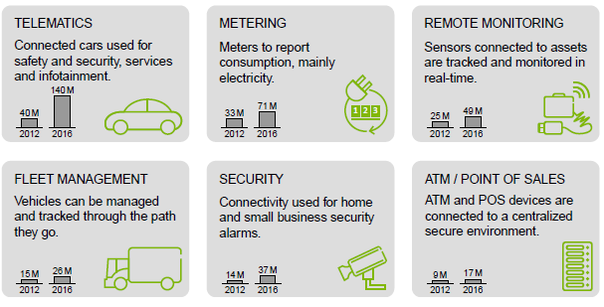

Fig 2.2. : Summarized cellular M2M Market situation

**IoT(Internet Of Things ):**

The IoT is a widely used term for a set of technologies, systems, and design principles associated with the emerging wave of Internet-connected things that are based on the physical environment.

In contrast to M2M, however, IoT also refers to the connection of such systems and sensors to the broader Internet, as well as the use of general Internet technologies.

IoT ecosystem will emerge not dissimilar to today’s Internet, allowing things and real world objects to connect, communicate, and interact with one another in the same way humans do via the web today.

No longer will the Internet be only about people, media, and content, but it will also include all real-world assets as intelligent creatures exchanging information, interacting with people, supporting business processes of enterprises, and creating knowledge (Figure 2.3). The IoT is not a new Internet, it is an extension to the existing Internet.



Fig 2.3 : Internet Of Things

IoT is about the

* Technology,
* Remote monitoring,
* Control, and

Also about where these technologies are applied.

IoT can have a focus on the open innovative promises of the technologies at play, and also on advanced and complex processing inside very confined and close environments such as industrial automation. When employing IoT technologies in more closed environments, an alternative interpretation of IoT could then be “Intranet of Things”.

**APPLICATIONS**:

IoT applications will not only rely on data and services from sensor and actuators alone. Equally important is the blend-in of other information sources that have relevance from the viewpoint of the physical world. These can be data from Geographic Information Systems (GIS) like road databases and weather forecasting systems, and can be of both a static nature and real-time nature. Even information extracted from social media like Twitter feeds or Facebook status updates that relate to real world observations can be fed into the same IoT system

We can point to examples of emerging application domains that are driven by different trends and interests (Figure 2.4). As can be seen, they are very diverse and can include applications like urban agriculture, robots and food safety tracing, and we will give brief explanations of what these three examples might look like.

**Urban Agriculture:**. Already today, more than 50% of the world’s population lives in urban areas and cities. The increased attention on sustainable living includes reducing transportation, and in the case of food production, reducing the needs for pesticides. The prospect of producing food at the place where it is consumed (i.e. in urban areas) is a promising. By using IoT technologies, urban agriculture could be highly optimized. Sensors and actuators can monitor and control the plant environment and tailor the conditions according to the needs of the specific specimen. Water supply through a combination of rain collection and remote feeds can be combined on demand. City or urban districts can have separate infrastructures for the provisioning of different fertilizers.Drainage can be provided so as not to spoil crops growing on facades and rooftops of buildings, as well as to take care of any recyclable nutrients. Weather and light can be monitored, and necessary blinds that can shield and protect, as well as create greenhouse microclimates, can be automatically controlled.

**Robots:** The mining industry turns into a fully automated and controlled operation. The process chain of the mine involving blasting, crushing, grinding, and ore processing will be highly automated and interconnected. The heavy machinery used will be remotely controlled and monitored, mine sites will be connected, and shafts monitored in terms of air and gases. As up to 50% of energy consumption in a mine can come from ventilation, energy savings can be done by very precise ventilation where the diesel vehicles are operating, and sensors in the mine can provide information about the location of the machines. The trend is also that local control rooms will be replaced by larger control rooms at the corporate headquarters. Sensors and actuators to remotely control both the sites and the massive robots in terms of mining machines for drilling, haulage, and processing are the instruments to make this happen

**Food Safety:** The main objective with FSMA (Food Safety and Modernization Act) is to ensure that the U.S. food supply is safe. Similar food safety objectives have also been declared by the European Union and the Chinese authorities. These objectives will have an impact across the entire Food supply chain, from the farm to the table, and require a number of actors to integrate various parts of their businesses. From the monitoring of farming conditions for plant and animal health, registration of the use of pesticides and animal food, the logistics chain to monitor environmental conditions as produce is being transported, and retailers handling of food all will be connected. Sensors will provide the necessary monitoring capabilities, and tags like radio frequency identification (RFID) will be used to identify the items so they can be tracked and traced throughout the supply chain.



FIG: 2.4 : IOT APPLICATIONS

**M2M towards IoT the global context**:

M2M solutions have been around for decades and are quite common in many different scenarios. Our planet is facing massive challenges environmental, social, and economic. The changes that humanity needs to deal with in the coming decades are unprecedented, not because similar things have not happened before during our common history on this planet, but because many of them are happening at the same time. The Vision resources to a reconfiguration of the world’s economy, many people are looking to technology to assist with these issues.

Essentially, therefore, a set of megatrends are combining to create needs and capabilities, which in turn produce a set of IoT Technology and Business Drivers. This is illustrated in Figure 2.5.

A megatrend is a pattern or trend that will have a fundamental and global impact on society at a macro level over several generations. It is something that will have a significant impact on the world in the foreseeable future. We here imply both game changers as challenges, as well as technology and science to meet these challenges



Fig 2.5 : Megatrends, Capabilities and Implications



**Game changers**: The game changers come from a set of social, economic, and environmental shifts that create pressure for solutions to address issues and problems, but also opportunities to reformulate the manner in which our world faces them. There is an extremely strong emerging demand for monitoring, controlling, and understanding the physical world, and the game changers are Working in conjunction with technological and scientific advances. More globally significant game changers below and their relationship to IoT:

**Natural Resource Constraints**. The world needs to increasingly do more with less, from raw materials to energy, water or food, the growing global population and associated economic growth demands put increasing constraints on the use of resources. The use of IoT to increase yields, improve productivity, and decrease loss across global supply chains is therefore escalating.

**Economic Shifts**. The overall economy is in a state of flux as it moves from the post-industrial era to a digital economy. One example of this is found in the move from product-oriented to service-oriented economies. Economies across the globe must handle the evolving nature of these forces. As technology becomes increasingly embedded and more tasks automated, countries need to manage this shift and ensure that M2M and IoT also create new jobs and industries.

**Changing Demographics**. With increased prosperity, there will be a shift in the demographic structures around the world. Many countries will need to deal with an aging population without increasing economic expenditure. As a result, IoT will need to be used.

**Socioeconomic Expectations**. The global emerging middle class results in increasing expectations on well-being and Corporate Social Responsibility. Lifestyle and convenience will be increasingly enabled by technology as the same disruption and efficiency practices evident in industries will be applied within people’s lives and homes as well.

**Climate Change and Environmental Impacts**. The impact of human activities on the environment and climate has been long debated, but is now in essence scientifically proven. Technology, including IoT, will need to be applied to aggressively reduce the impact of human activity on the earth’s systems.

**Safety and Security:**. Public safety and national security becomes more urgent as society becomes more advanced, but also more vulnerable. This has to do both with reducing fatalities and health as well as crime prevention, and different technologies can address a number of the issues at hand.

**Urbanization**: We see the dramatic increase in urban populations and discussions about megacities. Urbanization creates an entirely new level of demands on city infrastructures in order to support increasing urban populations. IoT technologies will play a central role in the optimization for citizens and enterprises within the urban realm, as well as providing increased support for decision-makers in cities.

**General technology and scientific trends:**

Technological and scientific advances and breakthroughs are occurring across a number of disciplines at an increasing pace. Below is a brief description of the science and technology advances that have a direct relevance to IoT.

**1. Material Science:**

It is large impact across a vast range of industries, from pharmaceutical and cosmetics to electronics. Micro Electro Mechanical Systems (MEMS) can be used to build advanced micro-sized sensors like accelerometers and gyroscopes. Emerging flexible and printable electronics will enable a new range of innovations for embedding technology in the real world. New materials provide different methods to develop and manufacture a large range of different sensors and actuator. Additionally, we will see other innovative uses such as smart textiles that will provide the capability to produce the next generation of wearable technologies. From an IoT perspective, these advances in material science will see an increasing range of applications and also a broader definition of what is meant by a sensor.

**2.** **Complex and Advanced Machinery:**

Itrefers to tools that are autonomous or semi-autonomous. Today they are used in a number of different industries; for example, robots and very advanced machinery is used indifferent harsh environments, such as deep-sea exploration, or in the mining industry in solutions such as Rio Tinto’s Mine of the Future Advanced machines have many modalities, and operate with a combination of local autonomous capabilities as well as remote control, Sensing and actuation are key technologies, and local monitor-control loops for routine tasks are required in addition to reliable communications for remote operations. These systems will continue to evolve and automate tasks today performed by humans - even self-driving cars.

**Energy Production and Storage:** It is relevant to IoT for two reasons. **Firstly**, it relates to the global interest of securing the availability of electricity while reducing climate and environmental impacts. Smart Grids, for example, imply micro-generation of electricity using affordable photovoltaic panels. In addition, smart grids also require new types of energy storage, both for the grid itself and for emerging technologies such as Electric Vehicles (EVs) that rely on increasingly efficient battery technologies.

**Secondly**, powering embedded devices in Wireless Sensor Networks (WSNs) will increasingly rely on different energy harvesting technologies and also rely on new miniaturized battery technologies and ultra-capacitors.

**Trends in information and communications technologies:**

**1. Devices: sensors, actuators, and tags function as the digital interfaces:**

Small-scale and cheap sensors and actuators provide the bridge between the physical realm and ICT systems. Tags using technologies such as RFID provide the means to put electronic identities on any object, and can be cheaply produced.

**2**. **EMBEDDED PROCESSING:**

Embedded processing is evolving, not only towards higher capabilities and processing speeds, but also extending towards the smallest of applications. There is a growing market for small-scale embedded processing such as 8-, 16-, and 32-bit microcontrollers with on-chip RAM and flash memory, I/O capabilities, and networking interfaces such as IEEE 802.15.4 that are integrated on tiny System-on-a-Chip (SoC) solutions. These enable very constrained devices with a small footprint of a few mm2 and very low power consumption (in the milli- to micro-Watt range),

3**. Instant access to the Internet:**

Instant access to the Internet is available virtually everywhere today, mainly thanks to wireless and cellular technologies and the rapid 2.3 M2M towards IoT the global context 23

deployment of cellular 3G and 4G or Long Term Evolution (LTE) systems on a global scale. These systems provide ubiquitous and relatively cheap connectivity with the right characteristics for many applications, including low latency and the capacity to handle large amounts of data with high reliability. Existing technologies can be further complemented with last hop technologies such as IEEE 802.15.4, Bluetooth Low Energy, and Power Line Communication (PLC) solutions to reach even the most cost sensitive deployments and tiniest devices. Technologies like 6LoWPAN allow IP connectivity to be provided end-to-end, stretching into the capillary network domain, and legacy and proprietary protocols like Zig Bee PRO can be avoided with the benefit of IP and the web anywhere. 3GPP are also extending LTE towards the lower end of the scale, providing very low power extensions targeting specific IoT applications

4. **Software architectures:**

Software architectures have undergone several evolutions over the past decades, in particular with the increasing dominance of the web paradigm**.** From a simplistic perspective, we can view software development techniques from what were originally closed environments towards platforms, where Open APIs provide a simple mechanism for developers to access the functionality of the platform in question(e.g. Microsoft Windows). Over time, these platforms, due to the increasing use and power of the Internet, have become open platforms ones that do not depend on certain programming languages or lock-in between platform developers and platform owners.

**5. service-oriented approach (SOA).:**

Software development has started applying the web paradigm and using a service-oriented approach (SOA). By extending the web paradigm to IoT devices, they can become a natural component of building any application and facilitate an easy integration of IoT device services into any enterprise system that is based on the SOA (e.g. that uses web services or REST ful interfaces). IoT applications can then become technology and programming language independent. This will help boost the IoT application development market.

**6. Open APIs**:

Open APIs relate to a common need to create a market between many companies, as is the case in the IoT market. Open APIs permit the creation Open APIs permit the creation allowing components to be combined together in multiple different ways by multiple developers with little to no interaction with those who developed the platform, Open APIs are the market’s response to this uncertainty; choice of how to combine components is left

to developers who are able to merely pick up the technical description and combine them together. Without Open APIs, a developer would need to create contracts with several different companies in order to get access to the correct data to develop the application. The transaction costs associated with establishing such a service would be prohibitively expensive for most small development companies; they would need to establish contracts with each company for the data required, and spend time and money on legal fees and business development with each individual company. Open APIs remove the need to create such contracts, allowing companies to establish “contracts” for sharing small amounts of data with one another and with developers dynamically, without legal teams, without negotiating contracts, and without even meeting one another. Open APIs therefore reduce the transaction costs associated with establishing a new market boundary.

7. **Cloud computing:**

The cloud computing paradigm, with different as a Service models, is one of the greatest aspects of the evolution of ICT for IoT as it allows virtualized and independent execution environments for multiple applications to reside in isolation on the same hardware platform, and usually in large data centers. Cloud computing allows elasticity in deployment of services and enables reaching long-tail applications in a viable fashion. It can be used to avoid in-house installations of server farms and associated dedicated IT service operations staff inside companies, thus enabling them to focus on their core business. Cloud computing also has the benefit of easing different businesses to interconnect if they are executing on the same platform. Handling of, for example, Service Level Agreements (SLAs) is easily facilitated with a high degree of control in a common virtualized environment. Cloud computing is also a key enabler when moving from a product-oriented offering to a service-oriented offering due to elasticity permitting companies to “pay-as-you-grow.”

**8. Data processing, intelligent software and big data :**

Data processing and intelligent software will have an increasing role to play in IoT solutions.

A popular concept now is big data, which refers to the increasing number and size of data sets that are available for companies and individuals to collect and perform analysis on. Built on large-scale computing, data storage ,in-memory processing, and analytics, big data is intended to find insights in the massive data sets produced. Naturally, these technologies

are therefore key enablers for IoT, as they allow the collation and aggregation of the massive datasets that devices and sensors are likely to produce.

The data collected from a vast quantity of sensors will help with the overall management of the project and ensure the health and safety of those working on it during the several months

that it is ongoing. It might only be a tiny piece of data from one sensor, however,that indicates a shift due to tunneling that may mean the collapse of a building on the surface. Whereas the aggregation of the data from all sensors can be usefully analyzed at intervals, the data related to subsidence and possible collapse of a building is critical and required in real-time.

**9. Decision support or even decision-making systems:**

Decision support or even decision-making systems will therefore become very important in different application domains for IoT, as will the set of tools required to process data, aggregate information, and create knowledge. Knowledge representation across domains and heterogeneous systems are also important, as are semantics and linked-data. As a result, we can expect to see an increased usage of cognitive technologies and self-learning systems.

**10. System integration and standards development.**

IoT solutions bring together devices, networks, applications, software platforms, cloud computing platforms, business processing systems, knowledge management, visualization, and advanced data analysis techniques. This is quite simply not possible at scale without significant levels of system integration and standards development**.**

**Differing characteristics:**

To summarize, today’s M2M solutions and deployments share a few common characteristics. First of all, any M2M solution is generally focused on solving a problem at a particular point for one company or stakeholder. It does not typically take a broad perspective on solving a larger set of issues or ones that could involve several stakeholders. As a result, most M2M

devices are special purpose devices that are application-specific, often down to the device protocols. M2M solutions are therefore also vertical siloes with no horizontal integration or connection to adjacent use cases, and are primarily of a B2B-type of operation. M2M applications are built by very specialized developers, and deployed inside enterprises. As M2M has a rather long history, technologies used are very industry-specific, and especially on the device side, technology use is highly fragmented with little or no standards across industries. M2M is also very device- and communication-centric, as both are the two current cornerstones for remote access to assets.

The transition from M2M towards an IoT is mainly characterized by moving away from the mentioned closed-silo deployments towards something that is characterized by openness, multipurpose, and innovation. This transition consists of a few main transformations, namely: moving away from isolated solutions to an open environment; the use of IP and web as a technology toolbox, the current Internet as a foundation for enterprise and government operations; multimodal sensing and actuation ;knowledge-creating technologies; and the general move towards a horizontal layering of both technology and business

**Comparison between m2m and IOT technologies**

|  |  |  |
| --- | --- | --- |
| **aspects** | **M2M** | **IOT** |
| **Applications and services** | Point problem driven | Innovation driven |
| Single application - single device | Multiple applications - multiple devices |
| Communication and device centric | Information and service centric |
| Asset management driven | Data and information driven |
| **Business** | Closed business operations | Open market place |
| Business objective driven Participatory | community driven |
| B2B | B2B, B2C |
| Established value chains | Emerging ecosystems |
| Consultancy and Systems Integration | Open Web and as-a-Service enabled |
| In-house deployment | Cloud deployment |
| **Technology** | Vertical system solution approach | Horizontal enabler approach |
| Specialized device solutions | Generic commodity devices |
| De facto and proprietary | Standards and open source |
| Specific closed data formats and service descriptions | Open APIs and data specifications |
| Closed software Development | Open software development |
| SOA enterprise integration | Open APIs and web development |

**A use case example**

In order to understand how a specific problem can be addressed withM2M and IoT, respectively, we provide a fictitious illustrative example. Our example takes two different approaches towards the solution, namely a n M2M approach and an IoT approach. By that, we want to highlight the potential and benefits of an IoT-oriented approach over M2M, but also indicate some key capabilities that will be required going beyond what can be achieved with M2M.

Measuring human stress can be done using sensors. Two common stress measurements are heart rate and galvanic skin response (GSR), and there are products on the market in the form of bracelets that can do such These sensors can only provide the intensity of the heart rate and GSR, and do not provide an answer to the cause of the intensity. A higher intensity can be the cause of stress, but can also be due to exercise. In order to analyze whether the stress is positive or negative, more information is needed The typical M2M solution would be based on getting sensor input from the person by equipping him or her with the appropriate device, in our case the aforementioned bracelet, and using a smartphone as a mobile gateway to send measurements to an application server hosted by a health service provider. In addition to the heart rate and GSR measurements, an accelerometer in the smartphone measures the movement of the person, thus providing the ability to correlate any physical activity to the excitement measurements. The application server hosts the necessary functionality to analyze the collected data, and based on experience and domain knowledge, provides an indication of the stress level. The stress information can then be made available to the person or a caregiver via smartphone application or a web interface on a computer. The M2M system solution and measured data is depicted in Figure

As already pointed out, this type of solution that is limited to a few measurement modalities can only provide very limited (if any) information about what actually causes the stress or excitement.



Causes of stress in daily life, such as family situation, work situation, and other activities cannot be identified. A combination of the stress measurement log over time, and a caregiver interviewing the person about any specific events at high levels of measured stress, could provide more insights, but this is a costly, labor-intensive, and subjective method. If additional contextual information could be added to the analysis process, a much more accurate stress situation analysis could potentially be performed.

**IOT SOLUTION**

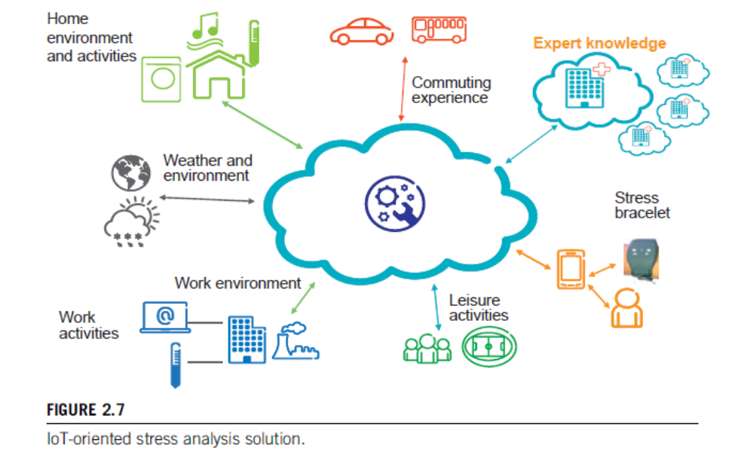

Approaching the same problem situation from an IoT perspective would be to add data that provide much deeper and richer information of the person’s contextual situation. The prospect is that the more data is available, the more data can be analyzed and correlated in order to find patterns and dependencies. What is then required is to capture as much data about the daily activities and environment of the person as possible .The data sources of relevance are of many different types, and can be openly available information as well as highly personal information. The resulting IoT solution is shown in Figure, where we see examples of a wide variety of data sources that have an impact on the personal situation. Depicted is also the importance of having expert domain knowledge that can mine the available information, and that can also provide proposed actions to avoid stressful situations or environments.

The environmental aspects include the physical properties of the specific environment, and can be air quality and noise levels of the work environment, or the nighttime temperature of the bedroom, all having impacts on the person’s well-being. Work activities can include the amount of e-mails in the inbox or calendar appointments, all potentially having a negative impact on stress. Leisure activities, on the other hand,

can have a very positive impact on the level of excitement and stress, and

can have a more healing effect than a negative effect.

**Merits**

* As this simple example illustrates, an IoT-oriented solution to solving a particular problem could provide much more precision in achieving the desired results.
* To take many different data sources into account, relying both on sensor-originated data sources, but also other sources that have to do with the physical environment, and then also to rely on both
* openly available data as well as data that is private and personal.
* The data sources, such as sensor nodes, should also focus on providing the information
* and should to the greatest extent be application-independent so that
* their reuse can be maximized.
* We also see the central role of analytics and knowledge extraction, as well as taking knowledge into actionable services that can involve controlling the physical environment using actuators.
* The increased complexity also comes at a cost. The solutions must ensure security and protection of privacy,
* The need to deal with data and information of different degrees of accuracy and quality needs to be addressed in order to provide dependable solutions in the end.